VOICE CONTROLLED VIRTUAL ASSISTANT

PROJECT REPORT

Agile Development Methodologies
Subject Code: IBD413

Project Guide:  Mr. Pritam Mohanta  IBM SME  CCSIT, TMU | Submitted By:  Mann Garg (TCA2457011)  Hamza Beg (TCA2457012)  Palak Chauhan (TCA2457015)  Samriddhi Goyal (TCA2457020)

January – June, 2026



COLLEGE OF COMPUTING SCIENCES & INFORMATION TECHNOLOGY
TEERTHANKER MAHAVEER UNIVERSITY, MORADABAD
Bachelor of Technology (IBM)

Certificate
This is to certify that the project entitled “Voice Controlled Virtual Assistant” has been carried out by Mann Garg (TCA2457011), Hamza Beg (TCA2457012), Palak Chauhan (TCA2457015), and Samriddhi Goyal (TCA2457020), students of Bachelor of Technology (IBM), College of Computing Sciences & Information Technology, Teerthanker Mahaveer University, Moradabad, under my guidance and supervision.
This project has been submitted in partial fulfilment of the requirements for the course Agile Development Methodologies (IBD413) for the academic session January – June, 2026.

Project Guide:  Mr. Pritam Mohanta  IBM SME, CCSIT, TMU | Head of Department:  Dr. Amit Singh  CCSIT, TMU

Declaration
We, the undersigned students of Bachelor of Technology (IBM), College of Computing Sciences & Information Technology, Teerthanker Mahaveer University, Moradabad, hereby declare that the project report entitled “Voice Controlled Virtual Assistant” is our original work carried out during the academic session January – June, 2026.
We further declare that this project work has not been submitted elsewhere, either fully or partially, for the award of any other degree or diploma. All information and content included in this report has been gathered and presented with due diligence and to the best of our knowledge.

Mann Garg (TCA2457011) Date: ___________
Hamza Beg (TCA2457012) Date: ___________
Palak Chauhan (TCA2457015) Date: ___________
Samriddhi Goyal (TCA2457020) Date: ___________

Acknowledgement
We take this opportunity to express our heartfelt gratitude to all those who have contributed to the successful completion of this project.
First and foremost, we are deeply grateful to our project guide, Mr. Pritam Mohanta, for his constant support, valuable guidance, and encouragement throughout the development of this project. His insights and constructive feedback have been instrumental in shaping this work.
We extend our sincere thanks to the faculty members of the College of Computing Sciences & Information Technology, Teerthanker Mahaveer University, Moradabad, for providing us with the necessary resources and a conducive environment for learning and project development.
We are also thankful to the Head of the Department and the university administration for their continued support and for providing access to the required laboratory facilities.
Finally, we would like to thank our parents, family members, and friends for their unwavering support and motivation throughout this journey.

Team Mann
B.Tech (IBM) – Semester IV

Index
Certificate 2
Declaration 2
Acknowledgement 2
Index 2
Abstract 2
Chapter 1: Introduction 2
1.1 Overview 2
1.2 Motivation 2
1.3 Objectives 2
1.4 Report Organization 2
Chapter 2: Problem Statement 2
2.1 Existing Challenges 2
2.2 Need for a Voice-Based Solution 2
Chapter 3: Project Description 2
3.1 Overview of the System 2
3.2 Key Features 2
3.3 Scope of the Work 2
Chapter 4: System Modules 2
4.1 Speech Recognition Module 2
4.2 Command Processing Module 2
4.3 Execution Module 2
4.4 Voice Response Module 2
4.5 Graphical User Interface Module 2
Chapter 5: Implementation Methodology 2
5.1 Development Approach 2
5.2 System Architecture and Flow 2
5.3 Implementation Phases 2
5.4 Testing 2
Chapter 6: Technologies Used 2
6.1 Programming Language – Python 2
6.2 SpeechRecognition Library 2
6.3 pyttsx3 – Text-to-Speech 2
6.4 Wikipedia API 2
6.5 Webbrowser & OS Modules 2
6.6 Tkinter – GUI Framework 2
6.7 Hardware & Software Requirements 2
Chapter 7: System Design 2
7.1 System Architecture 2
7.2 Context Diagram (Data Flow Diagram – Level 0) 2
7.3 Use Case Description 2
7.4 Module Interaction 2
Chapter 8: Advantages of the Project 2
8.1 Hands-Free Interaction 2
8.2 Enhanced Accessibility 2
8.3 Time Efficiency 2
8.4 User-Friendly Interface 2
8.5 Open-Source and Lightweight 2
8.6 Extensibility 2
Chapter 9: Future Scope and Enhancements 2
9.1 Artificial Intelligence Integration 2
9.2 Mobile Application Development 2
9.3 Smart Home Automation 2
9.4 Multi-Language Support 2
9.5 Improved Noise Handling and Offline Functionality 2
9.6 Personalization and Learning 2
9.7 Integration with Productivity Tools 2
Chapter 10: Conclusion 2
References 2

Abstract
In the modern technological landscape, voice-based interaction with computing systems has emerged as one of the most intuitive and efficient modes of human-computer communication. The “Voice Controlled Virtual Assistant” is a Python-based desktop application designed to perform a wide range of tasks through simple spoken commands from the user.
The system leverages the SpeechRecognition library to capture and convert user speech into text, processes the recognized text to determine the intended command, and executes the corresponding task. These tasks include opening system applications, performing internet searches, retrieving information from Wikipedia, reporting the current time, and providing spoken feedback to the user using the pyttsx3 text-to-speech engine.
The application includes a Graphical User Interface (GUI) developed using Tkinter, which enhances usability and makes interaction more accessible, especially for non-technical users. The project demonstrates the practical application of Python libraries in the domain of Artificial Intelligence and Human-Computer Interaction (HCI).
Although limited to basic desktop automation in its current form, the project lays a strong foundation for future enhancements such as integration with machine learning models, multi-language support, offline functionality, and smart home automation. This report documents the complete development process including system design, module description, implementation methodology, technologies used, advantages, and future scope of the Voice Controlled Virtual Assistant.

Chapter 1: Introduction

1.1 Overview
The rapid advancement of technology has transformed the way humans interact with computers. Traditional input methods such as keyboards and mice, although widely used, impose physical constraints and are not always the most efficient means of interaction, particularly for multitasking users or individuals with physical limitations.
Voice-controlled systems represent a significant leap in Human-Computer Interaction (HCI). By allowing users to communicate with machines through natural spoken language, these systems make computing more accessible, intuitive, and efficient. The success of commercially available virtual assistants such as Apple’s Siri, Amazon’s Alexa, Google Assistant, and Microsoft’s Cortana has demonstrated the enormous potential and public acceptance of voice-based interaction.
Inspired by these developments, this project presents a desktop-based Voice Controlled Virtual Assistant built using Python. Unlike commercial assistants that rely on large-scale cloud infrastructure and proprietary algorithms, this project focuses on a lightweight, open-source implementation that demonstrates the core functionality of a voice assistant using freely available Python libraries.

1.2 Motivation
The primary motivation behind this project is to address the need for a hands-free, accessible, and efficient method of interacting with computer systems. Conventional input devices demand full attention and physical dexterity, which can be limiting in many scenarios — for instance, when a user is cooking, driving, or has a physical impairment.
Voice interfaces reduce friction in human-computer interaction by allowing users to simply speak their intent. This project was motivated by the desire to explore and implement core voice recognition and automation techniques in a practical, real-world application using Python’s robust library ecosystem.

1.3 Objectives
The key objectives of this project are:
- To develop a functional voice-controlled desktop assistant using Python.
- To implement accurate speech recognition using the SpeechRecognition library.
- To enable the assistant to execute tasks including web search, application launch, Wikipedia queries, and time reporting.
- To provide spoken feedback to the user through text-to-speech synthesis.
- To build an interactive Graphical User Interface (GUI) using Tkinter.
- To test the system under different conditions to ensure reliability and accuracy.

1.4 Report Organization
This report is organized into ten chapters. Chapter 1 provides an introduction and background. Chapter 2 covers the problem statement. Chapter 3 describes the project and its scope. Chapter 4 details the system modules. Chapter 5 explains the implementation methodology. Chapter 6 outlines the technologies used. Chapter 7 discusses system design. Chapter 8 lists the advantages. Chapter 9 addresses future scope. Chapter 10 concludes the report, followed by references.

Chapter 2: Problem Statement

2.1 Existing Challenges
In today’s digital world, computers have become an indispensable tool for both personal and professional tasks. Despite their widespread use, the primary methods of interacting with computers — keyboards and mice — have remained largely unchanged for several decades. These traditional input methods, while effective for many users, come with a number of limitations:
- Physical Constraints: Users must maintain a fixed posture and use both hands, which restricts mobility and multitasking capability.
- Accessibility Issues: Individuals with physical disabilities such as motor impairments, arthritis, or paralysis find it difficult or impossible to use conventional input devices effectively.
- Time Consumption: Typing-based interaction requires the user to navigate menus, open applications manually, and type search queries, which can be time-consuming for routine tasks.
- Cognitive Load: Simultaneously managing a computer task and another activity increases cognitive load, especially in professional environments where attention is divided.
- Situational Limitations: In environments such as while driving, cooking, or exercising, traditional input methods are impractical or unsafe.

2.2 Need for a Voice-Based Solution
These challenges highlight the need for an alternative and more natural interface for interacting with computers. A voice-based system addresses all of the above limitations by:
- Allowing hands-free operation, enabling users to interact with the computer while performing other tasks.
- Providing an accessible interface for users with physical limitations who cannot use a keyboard or mouse.
- Reducing the time and effort required to perform routine tasks such as launching applications, searching the web, or retrieving information.
- Enabling a more natural and intuitive mode of communication through spoken language.
The proposed Voice Controlled Virtual Assistant addresses these challenges by providing a practical, Python-based solution that enables users to interact with their computers through natural speech commands, thereby improving accessibility, efficiency, and overall user experience.

Chapter 3: Project Description

3.1 Overview of the System
The Voice Controlled Virtual Assistant is a software application developed in Python that enables users to interact with their computer through voice commands. The system captures audio input from the user via a microphone, processes it using a speech recognition engine, interprets the recognized command, and executes the appropriate action.
The assistant is capable of handling a variety of tasks, including but not limited to:
- Opening installed applications such as Notepad, Calculator, and web browsers.
- Performing web searches using the default internet browser.
- Retrieving summarized information from Wikipedia.
- Reporting the current date and time.
- Responding to user queries with synthesized voice output.
- Displaying a Graphical User Interface (GUI) for visual interaction.

3.2 Key Features
- Speech Recognition: Converts spoken user input into text using the SpeechRecognition library and Google Web Speech API.
- Command Interpretation: Parses recognized text to determine the user’s intent and maps it to predefined command functions.
- Task Execution: Executes various system-level and internet-based tasks based on the interpreted command.
- Text-to-Speech Output: Provides spoken feedback and responses using the pyttsx3 library, enabling a two-way voice interaction.
- Graphical Interface: Offers a clean and intuitive GUI built with Tkinter, displaying command history, responses, and status indicators.

3.3 Scope of the Work
The scope of this project encompasses development of a desktop-based voice assistant application for Windows OS, implementation of voice recognition, command processing, task execution, and voice response modules, integration with the Wikipedia API and web browser for information retrieval, development of a Tkinter-based GUI, and testing of the system under various conditions to validate performance.
The following are explicitly outside the current scope: deep learning-based conversational AI, emotion detection or sentiment analysis, full offline processing, mobile or web-based deployment, and smart home device integration.

Chapter 4: System Modules
The Voice Controlled Virtual Assistant is structured into five core modules, each responsible for a specific aspect of the system’s functionality. These modules work sequentially and in coordination to deliver a seamless voice interaction experience.

4.1 Speech Recognition Module
The Speech Recognition Module serves as the entry point of the system. It is responsible for capturing the user’s voice input through a connected microphone and converting the spoken words into a text string that can be further processed. This module uses the SpeechRecognition Python library, which provides a high-level interface for accessing various speech recognition engines and APIs. In this project, the Google Web Speech API is used as the backend engine due to its high accuracy and support for multiple languages. The module employs ambient noise adjustment to filter out background sounds before capturing the user’s voice, improving recognition accuracy in noisy environments.

4.2 Command Processing Module
The Command Processing Module receives the text output from the Speech Recognition Module and is responsible for interpreting the user’s intent. It analyzes the recognized text using keyword matching and conditional logic to identify which command the user wishes to execute. For example, if the recognized text contains the keyword “time”, the module routes the request to the time-reporting function. If it contains “search” or a specific website name, it routes the request to the web browsing function. This module acts as the brain of the assistant, making decisions based on the input it receives and delegating tasks to the Execution Module.

4.3 Execution Module
The Execution Module is responsible for carrying out the tasks identified by the Command Processing Module. It directly interacts with the operating system and external services to perform the requested operations. The specific functions include:
- Launching System Applications: Uses Python’s os and subprocess modules to open installed applications such as Notepad, Calculator, File Explorer, etc.
- Web Browsing: Uses the webbrowser Python module to open URLs in the default browser or perform Google searches based on the user’s query.
- Wikipedia Search: Uses the Wikipedia Python API to fetch concise summaries of topics and relay them back to the user.
- Time and Date Reporting: Uses Python’s datetime module to retrieve and announce the current time and date.

4.4 Voice Response Module
The Voice Response Module is responsible for converting the system’s text-based outputs into spoken audio that is delivered back to the user, creating a complete two-way voice interaction experience. This module uses the pyttsx3 library, which works offline and does not require an internet connection for speech synthesis. It supports both male and female voice configurations and allows control over speech rate, volume, and voice type.

4.5 Graphical User Interface Module
The Graphical User Interface (GUI) Module provides a visual front-end for the Voice Controlled Virtual Assistant. While the assistant is primarily voice-driven, the GUI enhances usability by providing a visual representation of the assistant’s actions and responses. The GUI is developed using Tkinter and includes a text display area showing recognized commands and responses, a status bar indicating whether the assistant is listening or idle, and Start/Stop buttons to control the listening mode. The GUI runs on the main application thread while speech recognition runs on background threads to ensure responsiveness.

Chapter 5: Implementation Methodology

5.1 Development Approach
The development of the Voice Controlled Virtual Assistant follows a structured and iterative approach. The project was developed in phases, with each phase focusing on the implementation and testing of individual modules before integrating them into a complete working system. The overall development process was guided by Agile principles, allowing for flexibility, regular testing, and incremental improvement.

5.2 System Architecture and Flow
The system follows a sequential pipeline architecture. The processing flow is: voice audio is captured from the microphone; the captured audio is processed by the Google Web Speech API which transcribes it to text; the text is analyzed by the Command Processing Module to identify user intent; the appropriate execution function is called; and finally the result is converted to speech by pyttsx3 and displayed on the GUI simultaneously.
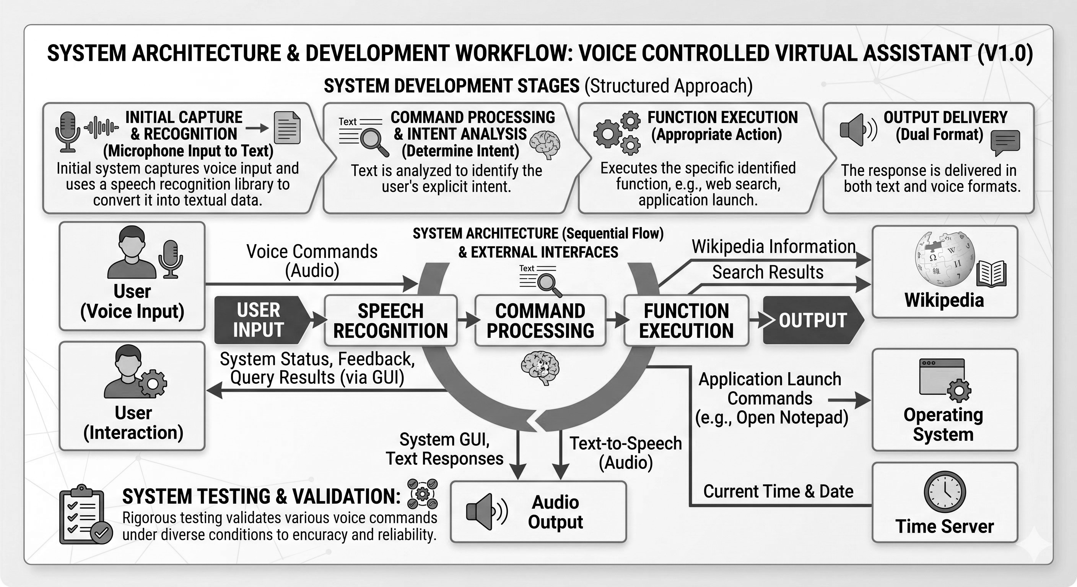
Figure 1: System Architecture & Development Workflow – Voice Controlled Virtual Assistant

5.3 Implementation Phases
Phase 1 – Environment Setup: Python was installed along with all required libraries: SpeechRecognition, pyttsx3, wikipedia, and Tkinter (built-in). A suitable IDE (VS Code or PyCharm) was configured for development.
Phase 2 – Core Module Development: Each module was implemented individually, starting with the Speech Recognition Module, then the Command Processing and Execution Modules.
Phase 3 – GUI Development: The Tkinter-based GUI was developed and integrated with backend modules to display recognized commands and responses in real time.
Phase 4 – Integration and Testing: All modules were integrated into a single cohesive application. Comprehensive testing was conducted by issuing various voice commands under different acoustic conditions.
Phase 5 – Refinement: Based on test results, adjustments were made to improve recognition accuracy, command handling logic, and GUI responsiveness.

5.4 Testing
The system was tested under multiple scenarios: clear environments with minimal noise (high accuracy observed), noisy environments with ambient sound (moderate accuracy; noise adjustment improved results), commands with different accents and speech speeds (generally recognized with minor errors), and unrecognized commands (system provided appropriate fallback responses). Testing confirmed that the system performs reliably under standard conditions.

Chapter 6: Technologies Used

6.1 Programming Language – Python
Python is the core programming language used in this project. Python was chosen for its simplicity, readability, and the extensive ecosystem of libraries available for AI, automation, and GUI development. Python’s rich library support made it possible to build a fully functional voice assistant without requiring low-level system programming.

6.2 SpeechRecognition Library
The SpeechRecognition library is a Python package that provides easy access to several speech recognition engines and APIs. In this project, it is used to capture audio from the microphone and send it to the Google Web Speech API for transcription. The library supports multiple backends including Sphinx, Wit.ai, and Google, making it flexible and extensible.

6.3 pyttsx3 – Text-to-Speech
pyttsx3 (Python Text-to-Speech version 3) is an offline text-to-speech conversion library for Python. It does not require internet connectivity, unlike some cloud-based TTS services. The library interfaces with the operating system’s native speech engine (SAPI5 on Windows) and allows customization of voice type, speech rate, and volume.

6.4 Wikipedia API
The Wikipedia Python package provides a simple interface to access Wikipedia’s content programmatically. In this project, it is used to retrieve concise summaries of topics queried by the user. The library returns structured text from Wikipedia articles, which is then read aloud by the Voice Response Module.

6.5 Webbrowser & OS Modules
The webbrowser module is part of Python’s standard library and is used to open URLs and perform Google searches based on user commands. The OS module provides a portable way of using operating system-dependent functionality and is used to launch system applications like Notepad and File Explorer.

6.6 Tkinter – GUI Framework
Tkinter is Python’s standard GUI library. It provides a fast and easy way to create desktop applications with windows, buttons, labels, text fields, and other UI components. Tkinter is built into Python and does not require separate installation.

6.7 Hardware & Software Requirements
- Computer or Laptop with a minimum of 4GB RAM.
- Microphone for capturing voice input (built-in or external).
- Operating System: Windows 10 or later.
- Stable internet connection for Google Speech API and Wikipedia access.
- Python 3.x – Core programming language.
- VS Code / PyCharm – IDE for development and debugging.

Chapter 7: System Design

7.1 System Architecture
The Voice Controlled Virtual Assistant follows a linear pipeline architecture where data flows sequentially from the user’s voice input through speech recognition, command processing, function execution, and finally to the output stage. Each stage in the pipeline is handled by a dedicated module, ensuring clean separation of concerns and ease of maintenance.

7.2 Context Diagram (Data Flow Diagram – Level 0)
The Context Diagram below illustrates all external entities interacting with the Voice Controlled Virtual Assistant system. The system receives voice commands from the user, queries external services such as Wikipedia and Internet Search Engine, sends application launch commands to the Operating System, retrieves time and date from the Time Server, and delivers output via both the display (GUI) and audio output (text-to-speech).
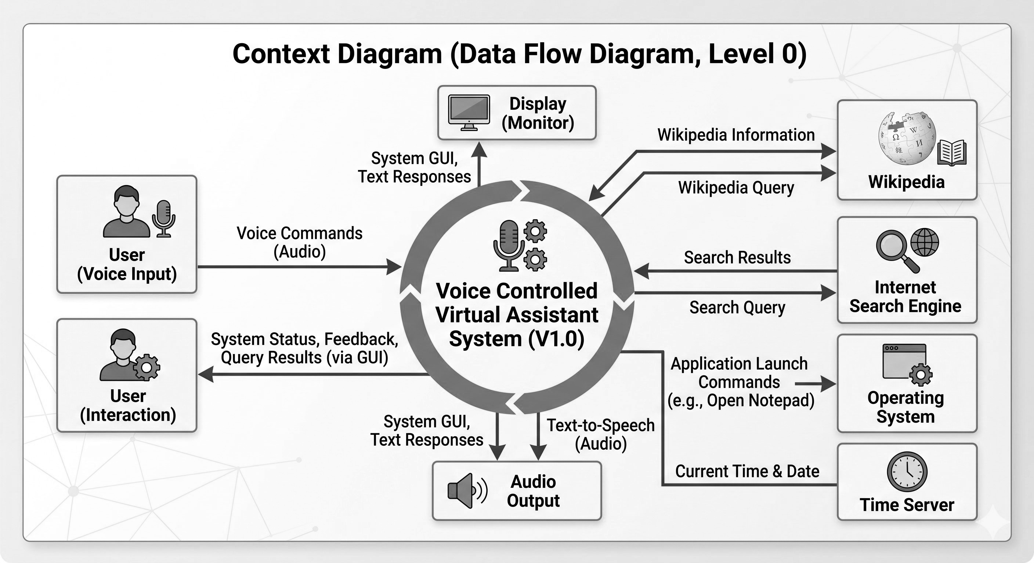
Figure 2: Context Diagram (Data Flow Diagram, Level 0) – Voice Controlled Virtual Assistant

7.3 Use Case Description
The primary actor in the system is the User. The following use cases describe the interactions supported by the system:
- Use Case 1 – Open Application: The user says ‘Open Notepad’. The system recognizes the command and launches Notepad on the user’s computer.
- Use Case 2 – Web Search: The user says ‘Search Python tutorial’. The system opens the default browser and performs a Google search.
- Use Case 3 – Wikipedia Query: The user says ‘Tell me about Artificial Intelligence’. The system fetches a summary from Wikipedia and reads it aloud.
- Use Case 4 – Time Query: The user says ‘What is the time?’. The system retrieves the current system time and announces it via voice.
- Use Case 5 – Unrecognized Command: The system responds with ‘Sorry, I did not understand that. Please try again.’

7.4 Module Interaction
All modules communicate through function calls and shared data variables. The Speech Recognition Module passes the recognized text to the Command Processing Module. The Command Processing Module calls functions in the Execution Module, which returns results. These results are passed to both the Voice Response Module and the GUI Module for output. Multithreading ensures that the GUI remains responsive while background processes handle speech recognition and execution.

Chapter 8: Advantages of the Project

8.1 Hands-Free Interaction
One of the most significant advantages of the Voice Controlled Virtual Assistant is that it enables entirely hands-free operation. Users can issue commands, search the internet, open applications, and receive responses without touching a keyboard or mouse. This is particularly beneficial in scenarios where physical interaction with a device is inconvenient or impossible, such as while cooking, driving, or exercising.

8.2 Enhanced Accessibility
The assistant significantly improves computer accessibility for individuals with physical limitations. Users with conditions such as motor impairments, arthritis, repetitive stress injuries, or paralysis can interact with their computers more easily using voice commands, eliminating the barrier imposed by conventional input devices.

8.3 Time Efficiency
By automating routine tasks such as opening applications, performing searches, and retrieving information, the assistant reduces the time and effort spent on repetitive activities. Users can complete tasks faster through voice commands compared to manually navigating through menus and typing queries.

8.4 User-Friendly Interface
The Tkinter-based GUI provides a clean and intuitive visual interface that complements the voice interaction. Even users who are unfamiliar with command-line tools or complex software can operate the assistant with ease. The combination of voice and visual feedback creates a smooth and accessible experience.

8.5 Open-Source and Lightweight
The project is built entirely using free and open-source Python libraries, making it cost-effective and easy to deploy. Unlike commercial voice assistants that require cloud subscriptions or proprietary hardware, this assistant runs entirely on a standard Windows PC with a microphone.

8.6 Extensibility
The modular architecture of the system makes it easy to extend with new commands and functionalities. Developers can add support for new APIs, applications, or automation tasks by simply defining new command handlers in the Execution Module, without modifying the core architecture.

Chapter 9: Future Scope and Enhancements

9.1 Artificial Intelligence Integration
The current system uses keyword-based command recognition, which is limited in its ability to handle complex or conversational inputs. In the future, the system can be enhanced by integrating advanced Natural Language Processing (NLP) models such as those built on transformer architectures (e.g., BERT, GPT-based models). This would enable the assistant to understand context, handle multi-turn conversations, and respond more intelligently to complex queries.

9.2 Mobile Application Development
The current implementation is limited to desktop environments running Windows. A future version of the assistant could be developed as a mobile application for Android and iOS platforms using frameworks such as Kivy or Flutter, significantly expanding its reach and utility.

9.3 Smart Home Automation
One of the most exciting future enhancements is the integration of the assistant with smart home devices. By connecting the assistant with IoT (Internet of Things) platforms such as Raspberry Pi or Home Assistant, users could control smart lights, fans, locks, and other home appliances through voice commands.

9.4 Multi-Language Support
The current system operates primarily in English. Future versions could incorporate multi-language support, allowing users to interact with the assistant in regional languages such as Hindi, Tamil, Marathi, and others. The Google Speech API already supports multiple languages, and adapting the Command Processing Module accordingly would make the assistant accessible to a much wider audience.

9.5 Improved Noise Handling and Offline Functionality
Future development could incorporate offline speech recognition engines such as Vosk or CMU Sphinx, which allow voice recognition without internet access. Additionally, improved noise-cancellation algorithms could make the assistant more reliable in loud environments.

9.6 Personalization and Learning
Future versions of the assistant could incorporate user profiling and personalization features. By learning user preferences, frequently used commands, and behavioral patterns over time, the assistant could offer proactive suggestions and customized responses, making it a more intelligent and personalized tool.

9.7 Integration with Productivity Tools
The assistant could be further enhanced by integrating it with popular productivity tools such as Google Calendar, Microsoft Outlook, to-do list applications, and note-taking tools. This would allow users to manage their schedules, set reminders, create notes, and send emails entirely through voice commands.

Chapter 10: Conclusion
The Voice Controlled Virtual Assistant project successfully demonstrates the practical application of Python-based speech recognition and automation technologies to create a functional and user-friendly desktop assistant. The project achieves its core objectives: capturing voice input, recognizing spoken commands, executing corresponding tasks, and providing voice-based feedback — all within a clean Graphical User Interface.
The system proves that even with lightweight, open-source tools, it is possible to build a capable voice assistant that addresses real-world challenges such as hands-free operation, accessibility, and task automation. The modular architecture ensures that the system is not only functional but also extensible, providing a solid foundation for future development.
Through this project, the team gained valuable hands-on experience in Python programming, library integration, speech processing, GUI development, and software testing. The collaborative development process, guided by Agile principles, further strengthened teamwork, communication, and problem-solving skills.
While the current implementation is limited in scope — primarily focused on basic desktop automation and keyword-based command handling — it represents a meaningful first step towards more intelligent, conversational, and context-aware voice assistants. The future enhancements outlined in Chapter 9 provide a clear and ambitious roadmap for evolving this project into a more sophisticated and widely applicable system.
In conclusion, the Voice Controlled Virtual Assistant stands as a testament to the power of voice-based human-computer interaction and its potential to make computing more accessible, efficient, and natural for all users.

References
[1] Python Software Foundation. Python 3.x Official Documentation. Available at: https://docs.python.org/3/
[2] SpeechRecognition Library Documentation. Available at: https://pypi.org/project/SpeechRecognition/
[3] pyttsx3 Library Documentation. Available at: https://pypi.org/project/pyttsx3/
[4] Wikipedia API Documentation. Available at: https://pypi.org/project/wikipedia/
[5] Tkinter Documentation – Python GUI Library. Available at: https://docs.python.org/3/library/tkinter.html
[6] Google Web Speech API. Available at: https://cloud.google.com/speech-to-text
[7] Python webbrowser Module Documentation. Available at: https://docs.python.org/3/library/webbrowser.html
[8] Python os Module Documentation. Available at: https://docs.python.org/3/library/os.html
[9] Lutz, M. (2013). Learning Python. O’Reilly Media.
[10] Various online tutorials and resources from GeeksforGeeks, Real Python, and Stack Overflow.

